An Old Farmer's Advice:
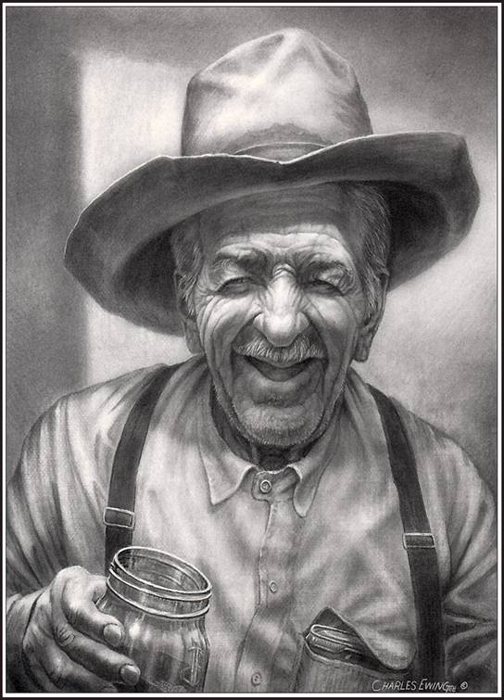
* Your fences need to be horse-high, pig-tight
and bull-strong.
* Keep skunks and bankers at a
distance.
* Life is simpler when you plow around the stump.
* A bumble bee is considerably faster than a
John Deere tractor.
* Words that soak into your ears are whispered...not yelled.
* Meanness don't jes' happen overnight.
* Forgive your enemies. It messes up their heads.
* Do not corner something that you know is meaner
than you.
* It don't take a very big person to carry a
grudge.
* You cannot unsay a cruel word.
* Every path has a few puddles.
* When you wallow with pigs, expect to get dirty.
* The best sermons are lived, not preached.
* Most of the stuff people worry about ain't
never gonna happen anyway.
* Don't judge folks by their relatives.
* Remember that silence is sometimes the best
answer.
* Live a good, honorable life. Then when you get
older and think back, you'll enjoy it a second time.
* Don't interfere with somethin' that ain't
botherin' you none.
* Timing has a lot to do with the outcome of a
rain dance.
* If you find yourself in a hole, the first thing to do is stop diggin'.
* Sometimes you get, and sometimes you get got.
* The biggest troublemaker you'll probably ever
have to deal with, watches you from
the mirror every mornin'.
* Always drink upstream from the herd.
* Good judgment comes from experience, and a
lotta that comes from bad judgment.
* Lettin' the cat outta the bag is a whole lot
easier than puttin' it back in.
* If you get to thinkin' you're a person of some
influence, try orderin' somebody else's dog around.
* Live simply. Love generously. Care deeply.
Speak kindly. Leave the rest to God.

As I've Matured

Happy Now | Geezers | Take Hold of the Moment | Mud Puddles

Home

